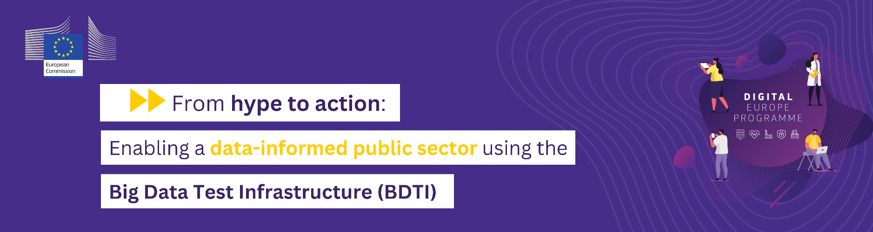

Big Data Test Infrastructure (BDTI)
Template Request Form

If you would like to run a pilot on the BDTI,
please fill this request form.
Once completed,
please send it back to:
EC-BDTI-PILOTS@ec.europa.eu

For more information,
please do not hesitate to visit our website

General applicant information
This part of the Pilot Request Template should be filled with the general information of the requesting organisation and its contact points.
Organisation Information
Name of the organisation
Name of the organisational unit / division / department
Address of the organisation
Public website
Public repository (e.g. GitHub)
Applicant Information
Name of the applicant
Title of the applicant
Applicant’s organisational unit / division / department
Applicant’s role in the organisation
E-mail address
Other contact point 1 | Name: |  | E-mail:
Other contact point 2 | Name: |  | E-mail:

General pilot information and Business requirements
This part should be filled with the specific information about the pilot and the business requirements. The applicant is also able select the additional business services offered by BDTI.
Pilot General
Pilot name
Pilot description
Addressed Use Case(s) | ☐ Predictive analysis  ☐ Network analysis  ☐ Time-series analysis  ☐ Social media analysis  ☐ Web Analysis (Scraping/Monitoring)  ☐ Population/Customer segmentation  ☐ Route-Traceability / Flow monitoring  ☐ Applying bioinformatics to genetic data | ☐ Descriptive analysis  ☐ Text analysis  ☐ Web Analysis  ☐ Image Processing  ☐ IoT & Smart City  ☐ IoT Security  ☐ Other Please specify
Pilot objective(s)
What positive impact do you expect from this pilot (I.e., for society, individuals...)?
Could there be negative effects from this pilot (I.e., for society, individuals)? Could it be used to target, profile or prejudice people, or unfairly restrict access (e.g. exclusive arrangements)?

Foreseen duration | Please select
Related Policy
Policy Domain | Please select
Stakeholders Involved
Stakeholder Name | Description

Technical requirements
This part should be filled with the pilot’s technical requirements which will be run by the requesting organisation. If the applicant is not able to fill this technical part, it can be filled in collaboration with any colleague skilled in IT, by adding his/her name as “other contact point” in the first section of this form.
Background and environment
Previous experiences | Please provide a summary of the previous relevant experience with big data analytics within your organisation. Do you have a public repository with existing and ongoing developments?
Experience with data products development | Please specify if you have already developed a data product. If yes, please specify which.
Available skilled resources | Please provide an overview of the technical profiles who will be involved in the pilot. Will a data scientist be part of the team? Do you have a data team?
Tools
Software Modules | Please enter the SW modules you need to run the pilot (e.g. Python pandas, Tensorflow, Spark, etc.)
Data
Data used* | Please explain briefly the type of data to be used and its source.
Pilot data sources (internal or third-party)
1st pilot data source | Name: | Give a name | Location: | Current location of dataset (e.g. on-premise, S3, etc.)
 | Ingestion: | API, FTP, Physical, etc. | Streaming: | Yes/ No
 | Data type: | Structured/Unstructured | Data format: | e.g. mpeg, .pdf, .html, .txt, .csv, etc.
 | Size: | Size in MB/ GB/ TB | Compressed: | Yes/ No
 | Open data | Yes/No | Frequency of updates | e.g. daily, monthly
 | Personal/ sensitive data involved | Yes/No
2nd pilot data source | Name: |  | Location:
 | Ingestion: |  | Streaming:
 | Data type: |  | Data format:
 | Size: |  | Compressed:
 | Open data | Yes/No | Frequency of updates | e.g. daily, weekly, monthly
 | Personal/ sensitive data involved | Yes/No
Please add more if you have more data sources
Computing
ELT requirements | e.g. multiple joins, filters, etc.
Compute infrastructure
Data analytics requirements
Machine learning branch | e.g. deep learning etc.
Visualisation
Used software/ tools | e.g. pyplot, plotly
Web access | Yes/ No
Data export formats | e.g. xml, .txt, .csv, etc.
Privacy & Security
Terms and conditions | ☐ I have read and agree to the terms and conditions (below).

Terms and conditions:
- Personal Data Protection

The European Commission is committed to user privacy. The policy on protection of individuals with regard to the processing of personal data by the European Union institutions is based on the Regulation (EU) 2018/1725 on the protection of personal data by the EU institutions, bodies, offices and agencies. Nevertheless, the pilot representatives are still the end responsible for processing personal or any other type of sensitive data during the pilot project.

- User Registration

When you register to our Service, we will open an account for you and you will be asked to provide us some personal information such as your first name, last name, email address and optionally your phone number. This information is required for creating a user account. Note that provided personal information might also be used by us for user identification, operational and security related matters.

Next, we will also ask you to choose a password for your user account. Please select a password that would not be obvious to someone trying to guess your password and change it regularly as an added precaution. You are responsible for maintaining the confidentiality of the password and account, and you are fully responsible for all activities that occur under your password or account identification. Note that user credentials or any other private information should not be shared with unauthorized users.

Whenever you provide us information, you agree to: (a) provide true, accurate, current and complete information and (b) maintain and promptly update such information to keep it true, accurate, current and complete. If you provide any information that is, or we have reasonable grounds to suspect that the information is, untrue, inaccurate, not current or incomplete, we may without notice suspend or terminate your access to our Service and refuse any and all current or future use of our Service (or any portion thereof). Furthermore, we reserve the right to correct any errors, inaccuracies or omissions and to change or update information within our service at any time, without prior notice.

- Data Security

The security of your data is important to us. We will take reasonable steps to help ensure the safety of private data (such as personally identifying information). However, you understand and agree that such steps do not guarantee that use of our Services is invulnerable to all security breaches, and no warranty, guarantee, or representation can be made that use of any of our Services is protected from viruses, security threats or other vulnerabilities.

- Acceptable use

With respect to our Services, you may not, and may not allow third parties, to:
- Use the services for any purpose that is unlawful or prohibited by these terms;
- Delete or change any copyright, trademark, or other proprietary notices;
- Attempt to obtain ownership or title to the online services, including the content;
- Use, copy, distribute, republish, display, disclose, upload, post, or transmit the online services in any commercial manner;
- Rent, lease, sell, sub-license, loan, translate, merge, adapt, assign or transfer the online services, or combine them with, or incorporate them into, any other programs or services;
- Disassemble, decompile, reverse-engineer, copy in source or object code format, or create derivative works based on the online services;
- Use or launch any unauthorized technology or automated system to access the online services or extract content from the online services, including but not limited to spiders, robots, screen scrapers, or offline readers;
- Attempt to disable, damage, overburden, impair or gain unauthorized access to the online services, our network or any user accounts associated with the online services.

